26th November 2019

**Salah Tahlak Gets Fourth Term on ATP International Group Council**

***Dubai Duty Free Tennis Championships Tournament Director is the only Arab to be re-elected for four consecutive terms***

**Summary:** Dubai Duty Free Executive Vice President for Corporate Services and Tournament Director of the Dubai Duty Free Tennis Championships, Salah Tahlak, has been re-elected for the fourth time as a Member of the ATP International Group Council for an additional three-year term, in an election conducted by the official body that runs the men’s professional tennis.

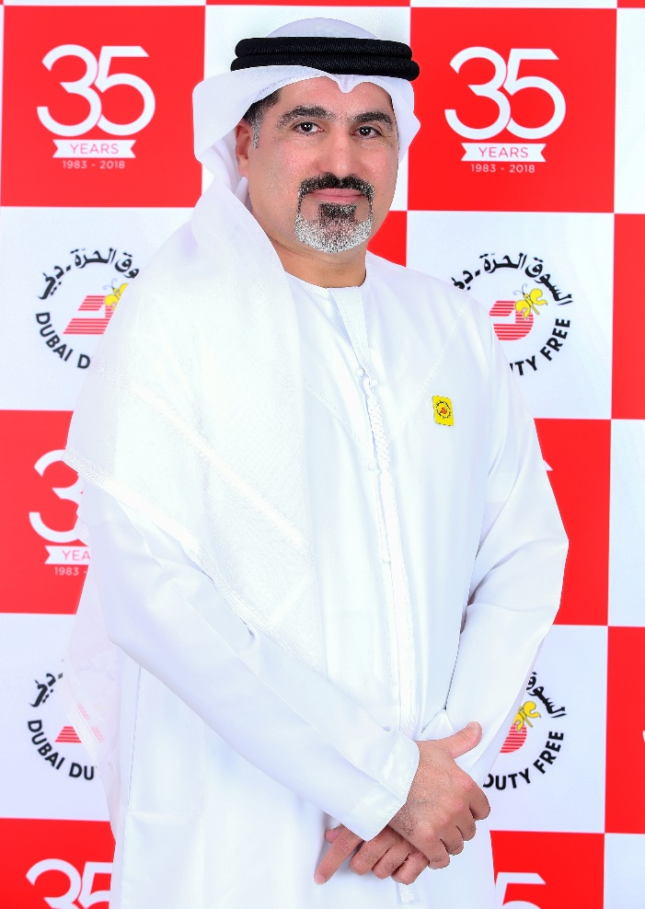

**Salah Tahlak, Executive Vice President - Corporate Services and Tournament Director - Dubai Duty Free Tennis Championships**

Dubai Duty Free Executive Vice President for Corporate Services and Tournament Director of the Dubai Duty Free Tennis Championships, Salah Tahlak, has been re-elected for the fourth time as a Member of the ATP International Group Council for an additional three-year term, in an election conducted by the official body that runs the men’s professional tennis.

A member of the ATP Global Tournament Council since 2010, Tahlak is the first and only Arab national to be re-elected for four consecutive terms. Tahlak, who has been involved with the DDF Tennis Championships since the beginning in 1993 served his first term on the ATP post from 2011 to 2014. He was then re-elected a second and third time to serve till 2019 and was inducted for a fourth time to serve till the end of 2022.

Tahlak was pleased with his re-election to the ATP post. “I am thankful for this opportunity to continue and serve as a Council Member of the ATP International Group for another three years. This is a great honour, and I am proud to represent Dubai Duty Free, Dubai and the UAE, as well as the wider Arab region in the world of tennis. I look forward to working closely with my fellow council members in the years to come.”

Colm McLoughlin, Executive Vice Chairman & CEO of Dubai Duty Free, added: “On behalf of Dubai Duty Free, I want to congratulate Salah on his recent re-election as a Council Member of the ATP International Group, and we will continue to support him and all the future activities of the ATP.”

Tahlak has been actively involved in the business of tennis since 1993, when Dubai Duty Free secured the first ATP tournament to be held in the UAE. The ATP event which is held under the Patronage of H.H. Sheikh Mohammed Bin Rashid Al Maktoum, Vice President and Prime Minister of the UAE and Ruler of Dubai, will mark its 28th anniversary next year with the tournament taking place from 17th – 29th February 2020 at the Dubai Duty Free Tennis Stadium.

* Ends –

For further information, please contact Bernard Aquino, Marketing Department,

Dubai Duty Free or call Tel: +9714-6019232 or email: [bernard.aquino@ddf.ae](mailto:bernard.aquino@ddf.ae)